Blue Cross Blue Shield BLUE ESSENTIALS Summary (as of August 11, 2017)

The ERS product design and the respective networks are described below: MAP
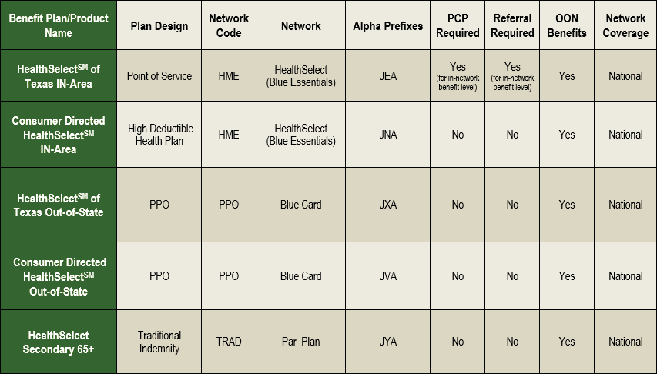
BCBSTX has split the POET service area into two areas. These are the POET North Service Area and the POET South Service Area. Below is a map to show how the areas are divided. The area determines which fee schedule is effective.
EXPLANATION
Same BCBSTX contract is in effect for both areas but with a primary office differential for the fee schedule.
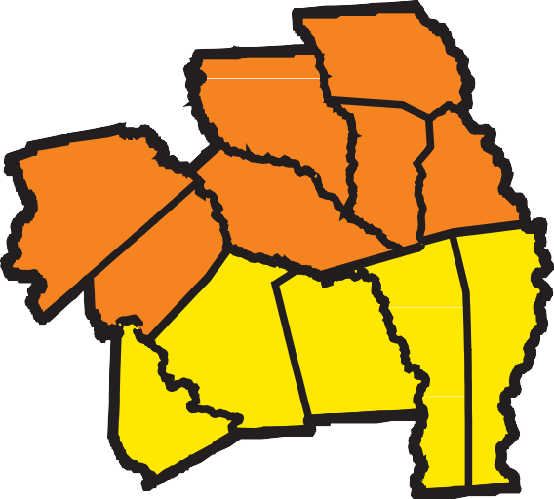
Shelby
Nacogdoches
Houston
Augustine
Sabine
San
Angelina
Trinity
Newton
Jasper
Polk
Tyler
Jacinto
San

As always please call POET with any questions you may have. (936) 637-7638 or email at staffadvocate@poetllc.org.

- HealthSelect of Texas In-Area Blue Essentials is an HMO product with selection of PCP required. Referrals are required for services to be covered at the in-network benefit level. Member has out of network benefits.
- Consumer Directed HealthSelect In-Area Blue Essentials may be referred to as HMO+. This plan does not require PCP selection and does not require referrals. In network providers for highest level of benefits. Member has out of network benefits.
OUT OF STATE
Coverage for out of state members. They must live out of state. (i.e. dependents, students) Will have suitcase logo on card. Both plans have out of network benefits.
- HealthSelect of Texas Out of State – No PCP required.
- Consumer Directed HealthSelect Out of State – No PCP required.
SECONDARY TO MEDICARE
- HealthSelect Secondary 65+ Employees eligible for Medicare as primary. No PCP required. Member has out of network benefits.
POET North Service Area POET South Service Area
POET NORTH
If physician's primary office is located in "POET North" (Angelina, Houston, Nacogdoches, Sabine, San Augustine, Shelby or Trinity counties) current PPO Fee Schedule applies.
POET SOUTH
If primary office is located in "POET South" (Jasper, Newton, Polk, San Jacinto or Tyler counties) a new Fee Schedule for this product will be used.

ERS Sample ID Cards

ERS HealthSelect of Texas ERS Consumer Directed HealthSelect Out-of-State

FRONT
BACK
FRONT
BACK

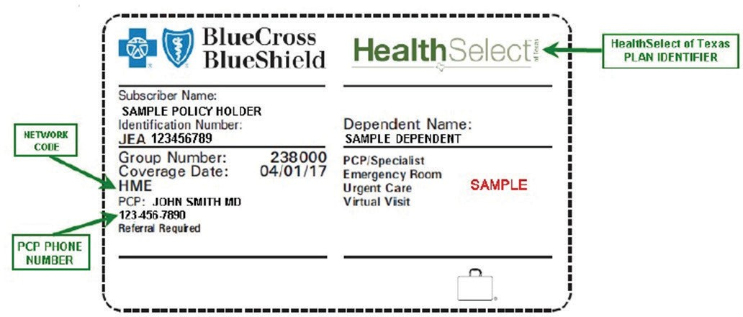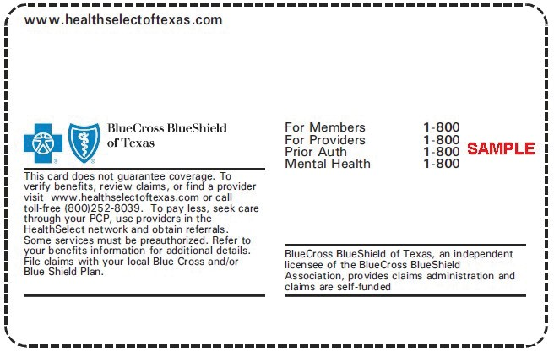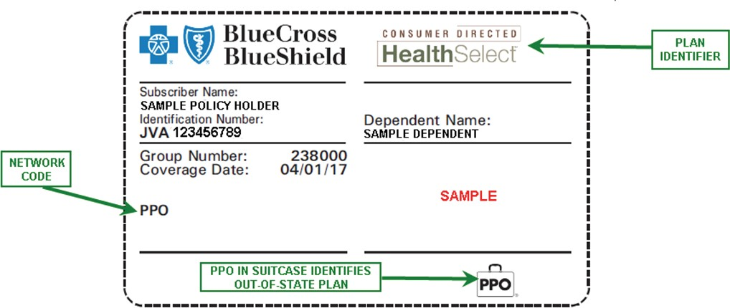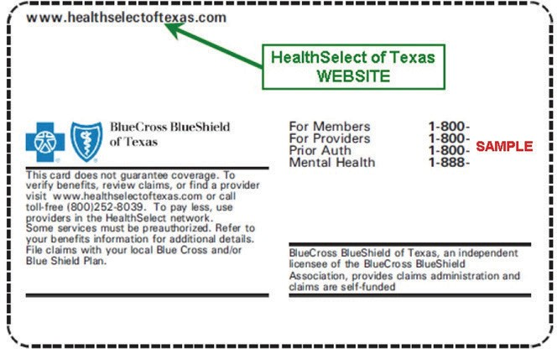

ERS Consumer Directed HealthSelect ERS HealthSelect Medicare Secondary

FRONT
BACK
FRONT
BACK

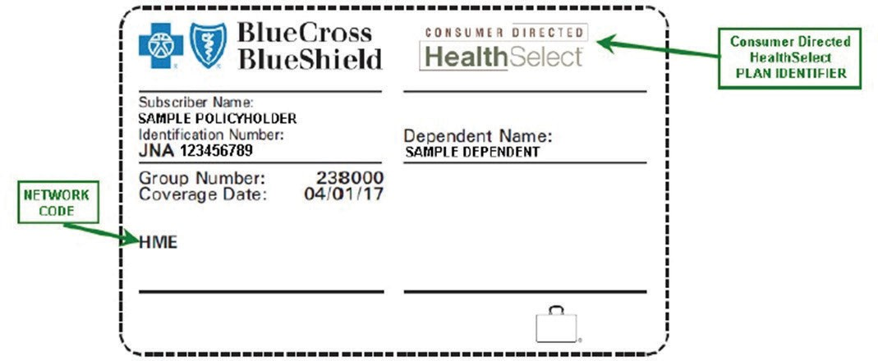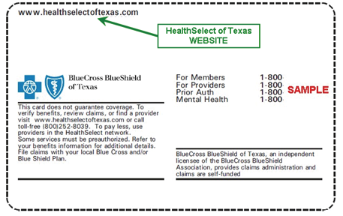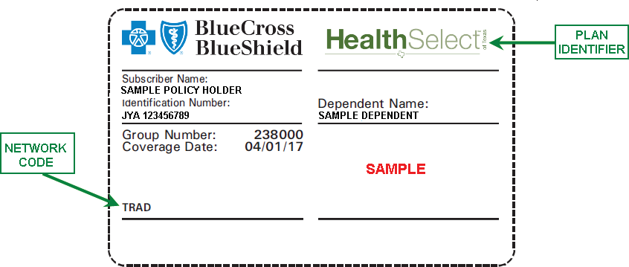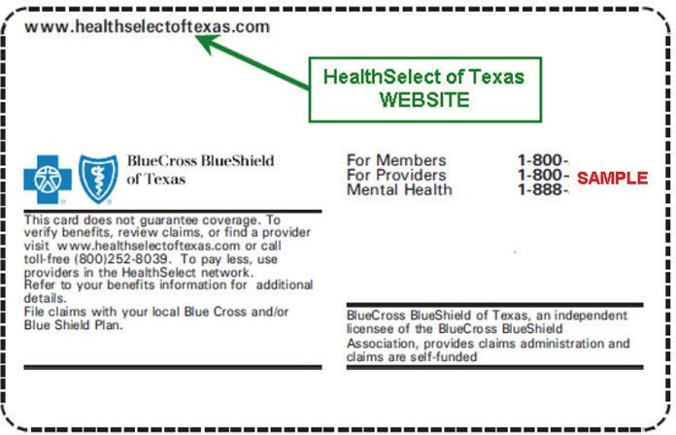
July 27, 2017

ERS HealthSelect Out-of-State

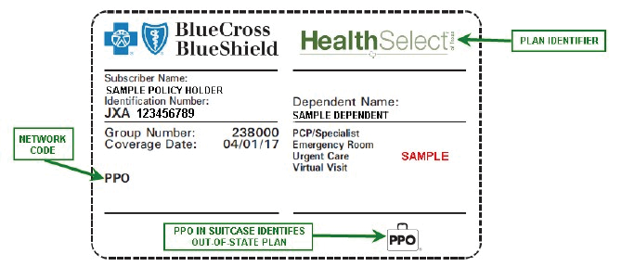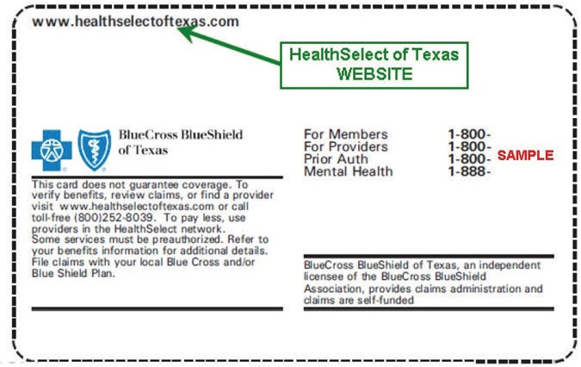FRONT

BACK
ERS Eligibility and Benefits
The HealthSelect of Texas and Consumer Directed HealthSelect (IN-Area and Out-of-State) and HealthSelect Secondary 65+ benefit designs include benefit changes from their previous administrator, so it’s important to check eligibility and benefits prior to rendering services.
Refer to the Eligibility and Benefits section on BCBSTX's provider website for additional information, such as definitions and links to helpful resources.

As always please call POET with any questions you may have. (936) 637-7638 or email at staffadvocate@poetllc.org.

