Medicaid Changes: POET Service Area (Updated September 24, 2020)
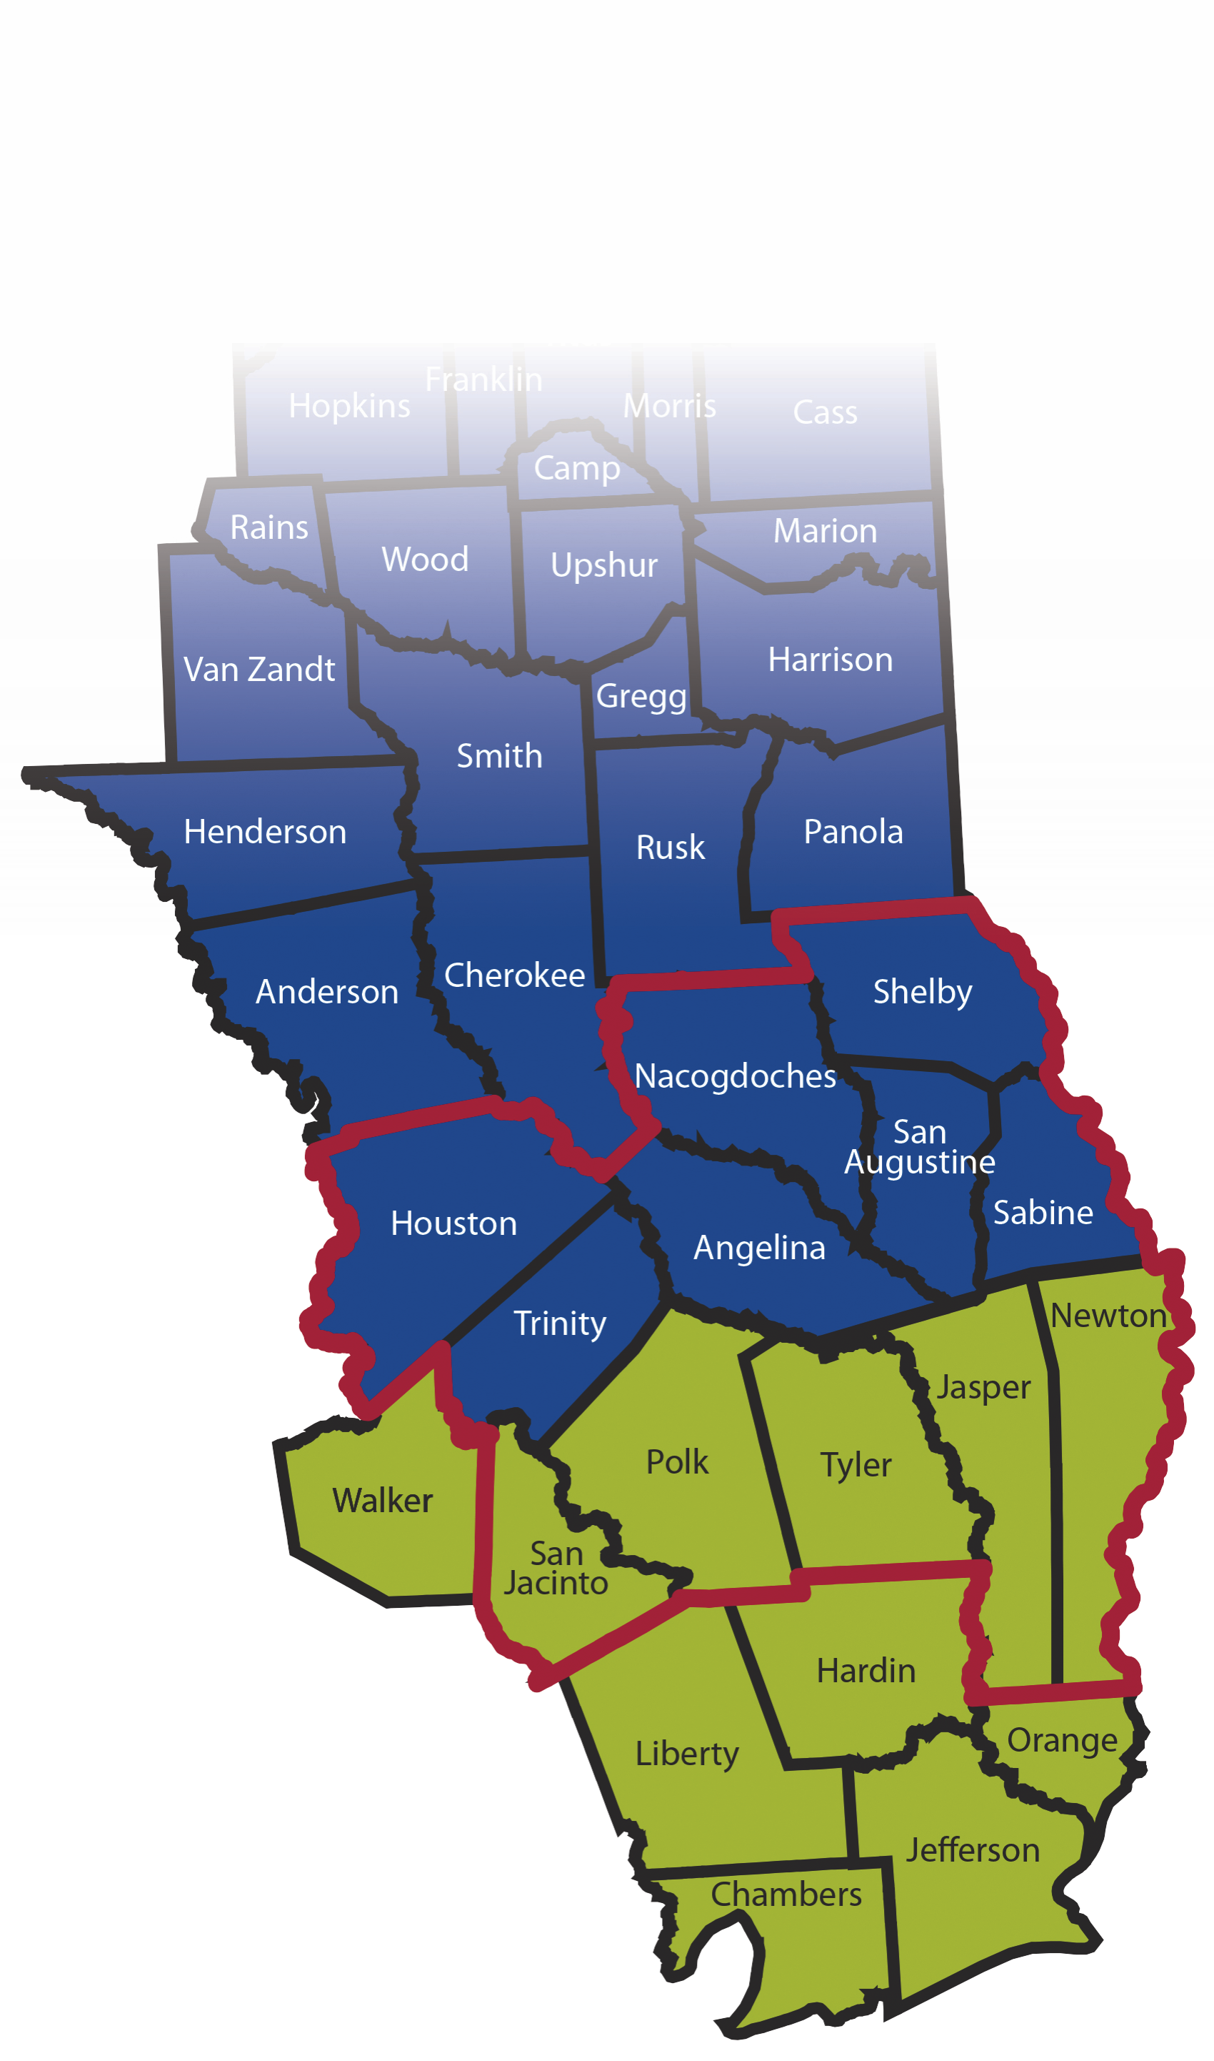
No changes in awarded products since May 2018, due to errors in the bidding process.
PRODUCTS AND HEALTH PLANS BY AREA
PRODUCTS
STAR Program: covers NON-disabled children, pregnant women and low-income parents.
STAR+ PLUS: covers the disabled (both adults and children) who are receiving Supplemental Security Income (SSI), including those who are dual eligible. However, a disabled member under the age of 21 may opt to stay in Traditional Medicaid. Patients living in Nursing homes are not eligible.
STAR Health: for children in foster care
CHIP: enrolls children from families whose family income is up to 200% of the federal poverty level, who do not qualify for Medicaid.
CHIP Perinatal: provides care to unborn children with household incomes up to 200% of the federal poverty level.
STAR Kids: for children and adults 20 or younger who have disabilities. Under STAR Kids, the patient receives basic medical and long-term services and supports through the health plan's provider network. And if eligible will receive Medically Dependent Children Program (MDCP) waiver services through the health plan's provider network.

MEDICAID SERVICE AREA

Medicaid has split the POET service area into two groups. These are the Medicaid Rural Service Area (MRSA) and the Jefferson Service Area (JSA). Each Service Area may have several Health Plans responsible for that area. Below is a map of how the areas are divided.

Items in RED are current POET contracts.
MRSA
Plan | MCO | Status
STAR Program | Amerigroup | N/A
STAR Program | Superior | Contracted
STAR+ PLUS | Cigna HealthSpring | Pending
STAR+ PLUS | UHC | Contracted
CHIP  Chip Perinatal | Superior | Contracted
STAR Health | Superior | Contracted
STAR Kids | Texas Children's | N/A
STAR Kids | UHC | Contracted

JSA
Product | Health Plan | Status
STAR Program | Amerigroup | N/A
STAR Program | Community Health | N/A
STAR Program | Molina | Contracted
STAR Program | Texas Children's | N/A
STAR Program | UHC | Contracted
STAR+ PLUS | Amerigroup | N/A
STAR+ PLUS | Molina | Contracted
STAR+ PLUS | UHC | Contracted
CHIP  Chip Perinatal | Amerigroup | N/A
CHIP  Chip Perinatal | Community Health | N/A
CHIP  Chip Perinatal | Molina | Contracted
CHIP  Chip Perinatal | Texas Children's | N/A
CHIP  Chip Perinatal | UHC | Contracted
STAR Health | Superior | Contracted
STAR Kids | Texas Children's | N/A
STAR Kids | UHC | Contracted

MEDICAID CARD
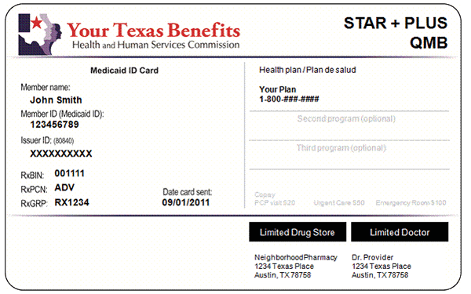
Below is a generic copy of the Medicaid Card.

Jefferson Service Area Medicaid Rural Service Area POET Service Area

As always please call POET with any
questions you may have.
(936) 637-7638 or email
Staffadvocate@poetllc.org



