Revenue cycle check-up: Assessing the internal components to get a clear picture of your practice’s financial health
INSIGHT ARTICLE - DECEMBER 16, 2020
BILLING & COLLECTIONS

REIMBURSEMENT

DATA ANALYTICS & REPORTING
Shawntea “Taya” Moheiser CMPE, CMOM
Kem Tolliver CMPE, CPC, CMOM

With fee-for-service almost in the rearview mirror and pay for quality now a reality, it’s time to transform the revenue cycle.
The drudgery of antiquated manual processes and the accumulated effects of burnout from a year of pandemic challenges may have you wondering where to begin with transforming from volume to value.
That’s where an internal revenue cycle assessment can be useful. Some activities, such as financial assessment, may require monthly review. Others — such as SWOT (strengths, weaknesses, opportunities, threats) analyses — are performed annually.
Financial statements
Accurate financial statements are a primary source of information for practice managers. Financial statements provide the information required to assess the current financial health of the organization and to predict its future financial health.
A series of reports should be reviewed regularly, including profit and loss statements, balance sheet, provider productivity, deposits (cash/credit/EFT), cash on hand, aging accounts receivables and general ledger.
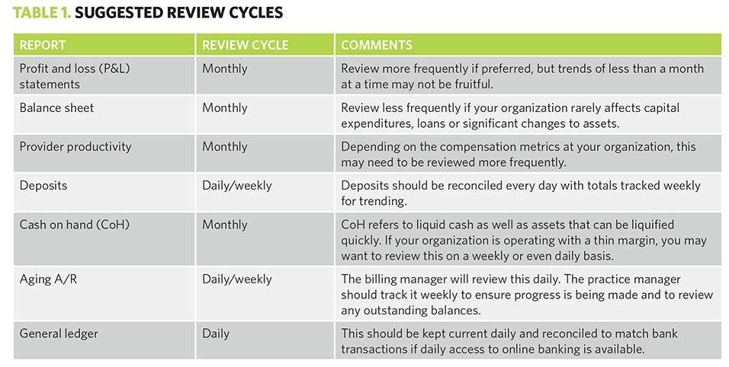
Table 1 offers suggestions for how often these reports should be reviewed, which may need to be adjusted based on the size of your organization and the roles/responsibilities of each employee.
Process assessments
Assessing practice processes should take place annually during the security risk assessment (SRA).1 When reviewing, you want to make sure that a high-level business process and workflows are in place for each department.
The U.S. Department of Health & Human Services (HHS) requires all covered entities (including healthcare providers) that access electronic protected health information (ePHI) to conduct a risk assessment as the first step toward knowing if required safeguards, as specified in the HIPAA Security Rule, are in place.
“Regardless of the size of the organization or the number of patients, patient records, or how much or how little ePHI is held, a risk assessment needs to be conducted,” said Jay Hodes, president, Colington Consulting. “A checklist will not suffice.”
Hodes said that an assessment must include a gap analysis, an overview examination to assess whether certain controls or safeguards required by the Security Rule are implemented, especially from the policy and procedure perspective. “A good risk assessment should include a mitigation plan that addresses how to fix or correct moderate to high levels of risk that were discovered,” Hodes added. “The HIPAA Security Rule states that a risk assessment must be documented and that the overall process of compliance is ongoing, meaning it’s not a ‘one and be done’ deal. The risk assessment will be one of the first documents requested by HHS as part of any breach investigation.”
While reviewing the business processes and workflows, look for duplication, gaps in the process/workflow, adherence to process/workflows, and perform a SWOT analysis.
SWOT analysis
A SWOT analysis may be tedious, but it’s critical to the health of the business. It helps you identify the strengths, weaknesses, opportunities and threats within your organization.
The layout of a SWOT organizer does not have to be overly complicated to be effective. There are many online resources to assist with implementing this process. [Member tool: Download a full SWOT matrix template to help evaluate business plans: mgma.com/swot-tool]
As with any assessment, managers and staff should be consulted to ensure that those who are involved in the workflow are providing critical information.
Site profitability
Site profitability is important to analyze so that resources can be allocated properly across your organization and to identify issues impeding profitability. You and your accountant should be able to set your locations as separate cost centers within your practice management system and accounting software so that you can receive accurate and meaningful reporting and expand upon existing cost centers as needed.
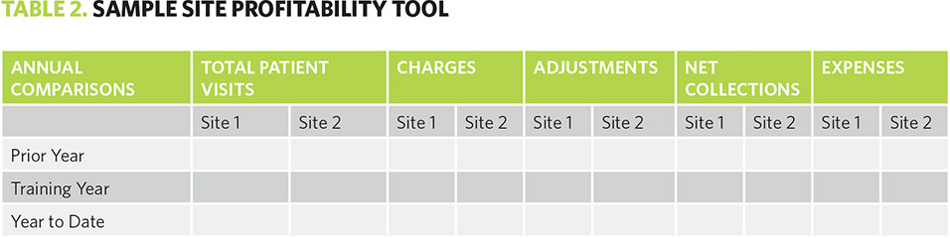
Table 2 is a snapshot of a sample site profitability tool. This type of evaluation assesses practice site profitability by comparing total patients, charges, adjustments, net collections and expenses across all locations for three years. Customize this sheet to fit the needs of your organization and review this information annually at minimum.
Provider compensation versus collections
Structuring provider compensation can involve very challenging and complex metrics. Regardless of complexity, it is critical to evaluate the net profit of each provider by evaluating the provider’s total compensation compared to total receipts.
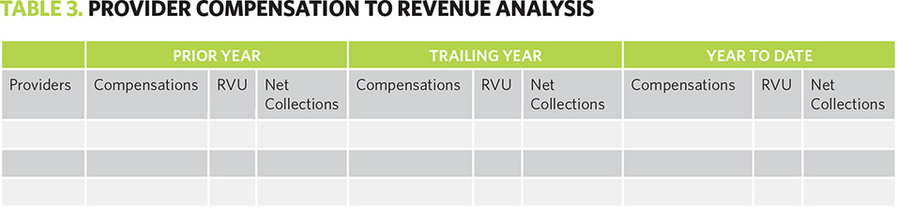
Table 3 is an example of how to set up a basic analysis that compares provider compensation to revenues. Even if you do not employ the use of relative value units (RVUs) as the basis of compensation, they are an excellent weighting tool to review productivity and compensation. At minimum, consider including RVUs as an incentive metric for bonuses or pay increases.
As noted by Kathy Maddock, BSN, MSA, FACMPE, LSSGB, president of Maddock & Co, RVU-based physician compensation continues to be the most common method when structuring clinical physician compensation. “The physician clinical effort can be directly tied to work RVUs (wRVUs) that are tied to CPT® codes, making the monitoring of productivity fairly simple,” Maddock said.
Maddock added that MGMA is one of the best sources for providing wRVU benchmark data that can help set productivity targets. “Although you will need to navigate the nuances of using wRVUs in compensation, it will also provide a solid foundation for basing physician compensation,” Maddock said.
Other assessment metrics
The other assessment metrics will vary based upon the size, setup and needs of your organization. Other useful assessments for RCM include an analysis of daily charges, credit balances and timeline, payer mix, incentive program performance, patient statements, denial rates and bad debt agency performance.
DAILY CHARGES
Some practices prefer to review daily charges every day while others may review them weekly or monthly. A review of daily charges identifies the billable productivity of the entire organization. Like provider productivity metrics, this assessment should review the procedure codes charged out alongside the units, or quantity, of those services billed. The primary difference between a daily charge analysis and a provider productivity analysis is that the former will also capture ancillary services or non-provider charges. For example, in-house pharmacy or laboratory charges should appear in the daily charges review.
PAYER MIX
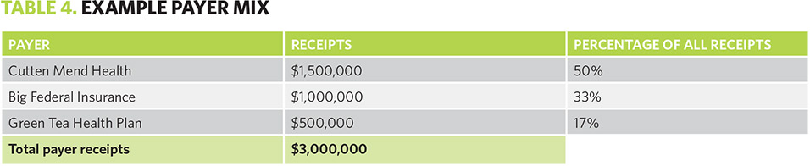
Payer mix is the ranking of insurance providers by charges. In Table 4, you can see the payer with the highest dollar amount of charges is Cutten Mend Health at 50% of the total volume of charges. An analysis of your payer mix tells you more about your patient population.
PAYER PRODUCTIVITY
In addition to payer mix, it’s prudent to run a payer productivity report regularly that ranks payers by receipts instead of charges.
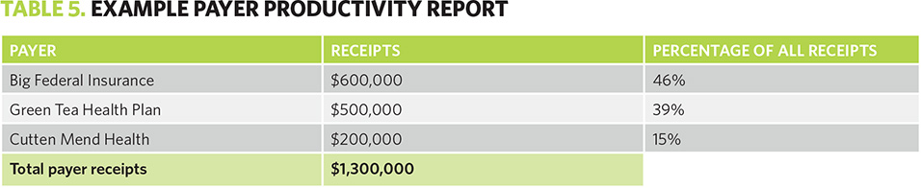
Table 5 shows quite a difference between charges and receipts. There are several immediate takeaways:
- Big Federal has the highest dollar value of receipts even though the charges were lower.
- Green Tea Health is paying 100% of charges, which indicates the master fee schedule may be too low.
- Cutten Mend Health, which represents 50% of our total charges, is reimbursing at only 15% overall. This indicates that the provider’s contract may be overdue for renegotiation.
Looking at data points across multiple reports will tell a story, which will enable you to trend data across several dimensions to determine the true root cause of any issue. For example, if you take the above example and then look at an A/R aging report, you may identify that though Cutten Mend Health has very low receipts, it’s more than 120 days behind in processing claims. If that’s the case, you should review your payer contracts for timely payment clauses. Contact the insurance payer and request interest payments where applicable.
If you aren’t sure where to find these reports, work with your practice management system vendor to locate or create them as needed.
LEARN MORE
It is easy to get lost in all the phases of revenue management, so how does a practice keep it all straight? Proven solutions to optimize revenue cycle are the key, and Revenue Cycle Management: Don’t Get Lost in the Financial Maze has them. In fact, this article is adapted from it. Whether you’re new to managing the revenue cycle or a seasoned professional, the concepts covered in this book are key to your success.
NOTE:
- Office of the National Coordinator for Health Information Technology. “Security Risk Assessment Tool.” Available from: bit.ly/3h95wMq.

